Psychology 1: Revision for First Test 2017

The first test will comprise mainly multiple choice and fill-the-gap questions.

Working through the online quizzes on this blog page would be ideal preparation:
http://psychologyrats.edublogs.org/essential-online-revision-unit-1-2017/

For the first test, these are the topics to study:
- Definition of psychology, including behaviour and mental states
- The difference between a behaviour, thought and feeling
- The goals of psychology
- The different kinds of research studies in psychology and their uses, benefits and limitations
- Some pages of this presentation will help you to revise these topics:
Introductory Presentation
- The seven steps in the scientific method (see your text) and the quiz below
- The differences between qualitative and quantitative data
- The history of our understanding of the brain (see your text, your notes and the quiz below)
- Neuro-imaging techniques
- Split-brain experiments
This presentation will help you to revise: Split-Brain Flow-Chart
- The nervous system and its components
- Structure of a neuron (?)
- The structure and function of brain areas (as summarised in your text on pp.122-127) (?)
Oh dear, I am not consciously aware that I have learned anything, but perhaps there is something lurking somewhere in my brain…
These Quizzes and Kahoots would be ideal preparation:

- Kahoot: Introduction to psychology and the brain
- Steps of the Scientific Method | PDF of quiz with answers
- Quiz on Suzana Herculano-Huzel’s presentation | PDF with answers
- Split-brain surgery quiz | PDF with answers
- Mr Split-Brainy Game
- Kahoot on the Split-Brain Experiments and other details of the nervous system
- Quiz on the components of the nervous system | PDF with answers
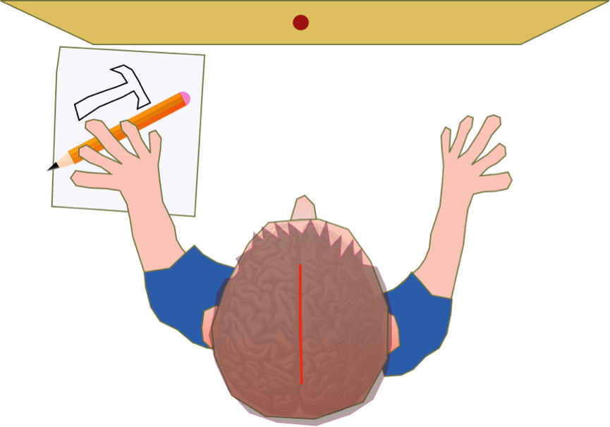
- Quiz on neuroimaging techniques | PDF with answers
- Kahoot: Brain structure and function
Split-brain patient having a crisis of confidence…

