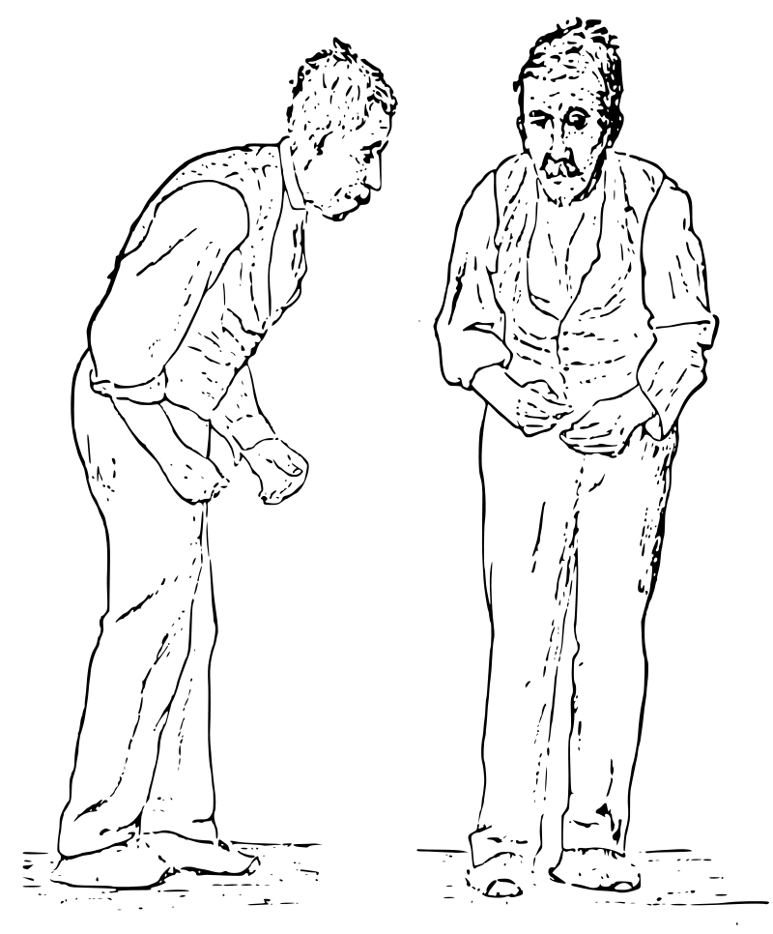
Parkinson’s Disease Notes
1 What is Parkinson’s Disease? (p.163)
2 Which change in the brain has been linked with Parkinson’s Disease? (second paragraph, p.163)
3 Describe the four key symptoms. (pp. 163-4)
4 What is the average age of diagnosis? (p.164)
5 How many people in Australia suffer from Parkinson’s Disease? (p.164)
6 Which two types of medications are used to treat Parkinson’s Disease? (pp.164-5)
7 Watch the video showing deep brain stimulation treatment at Monash Medical Centre. Why was it necessary and what were its effects?
Sketch showing the typical posture shown in Parkinson's Disease - 1886

Text: Grivas, Psychology, VCE Units 1 and 2, 7th edition

Parkinson’s Disease Notes
1 What is Parkinson’s Disease? (p.163)
2 Which change in the brain has been linked with Parkinson’s Disease? (second paragraph, p.163)
3 Describe the four key symptoms. (pp. 163-4)
4 What is the average age of diagnosis? (p.164)
5 How many people in Australia suffer from Parkinson’s Disease? (p.164)
6 Which two types of medications are used to treat Parkinson’s Disease? (pp.164-5)
7 Watch the video showing deep brain stimulation treatment at Monash Medical Centre. Why was it necessary and what were its effects?
Sketch showing the typical posture shown in Parkinson's Disease - 1886

Text: Grivas, Psychology, VCE Units 1 and 2, 7th edition

Parkinson’s Disease Notes
1 What is Parkinson’s Disease? (p.163)
2 Which change in the brain has been linked with Parkinson’s Disease? (second paragraph, p.163)
3 Describe the four key symptoms. (pp. 163-4)
4 What is the average age of diagnosis? (p.164)
5 How many people in Australia suffer from Parkinson’s Disease? (p.164)
6 Which two types of medications are used to treat Parkinson’s Disease? (pp.164-5)
7 Watch the video showing deep brain stimulation treatment at Monash Medical Centre. Why was it necessary and what were its effects?
Sketch showing the typical posture shown in Parkinson's Disease - 1886

Text: Grivas, Psychology, VCE Units 1 and 2, 7th edition

