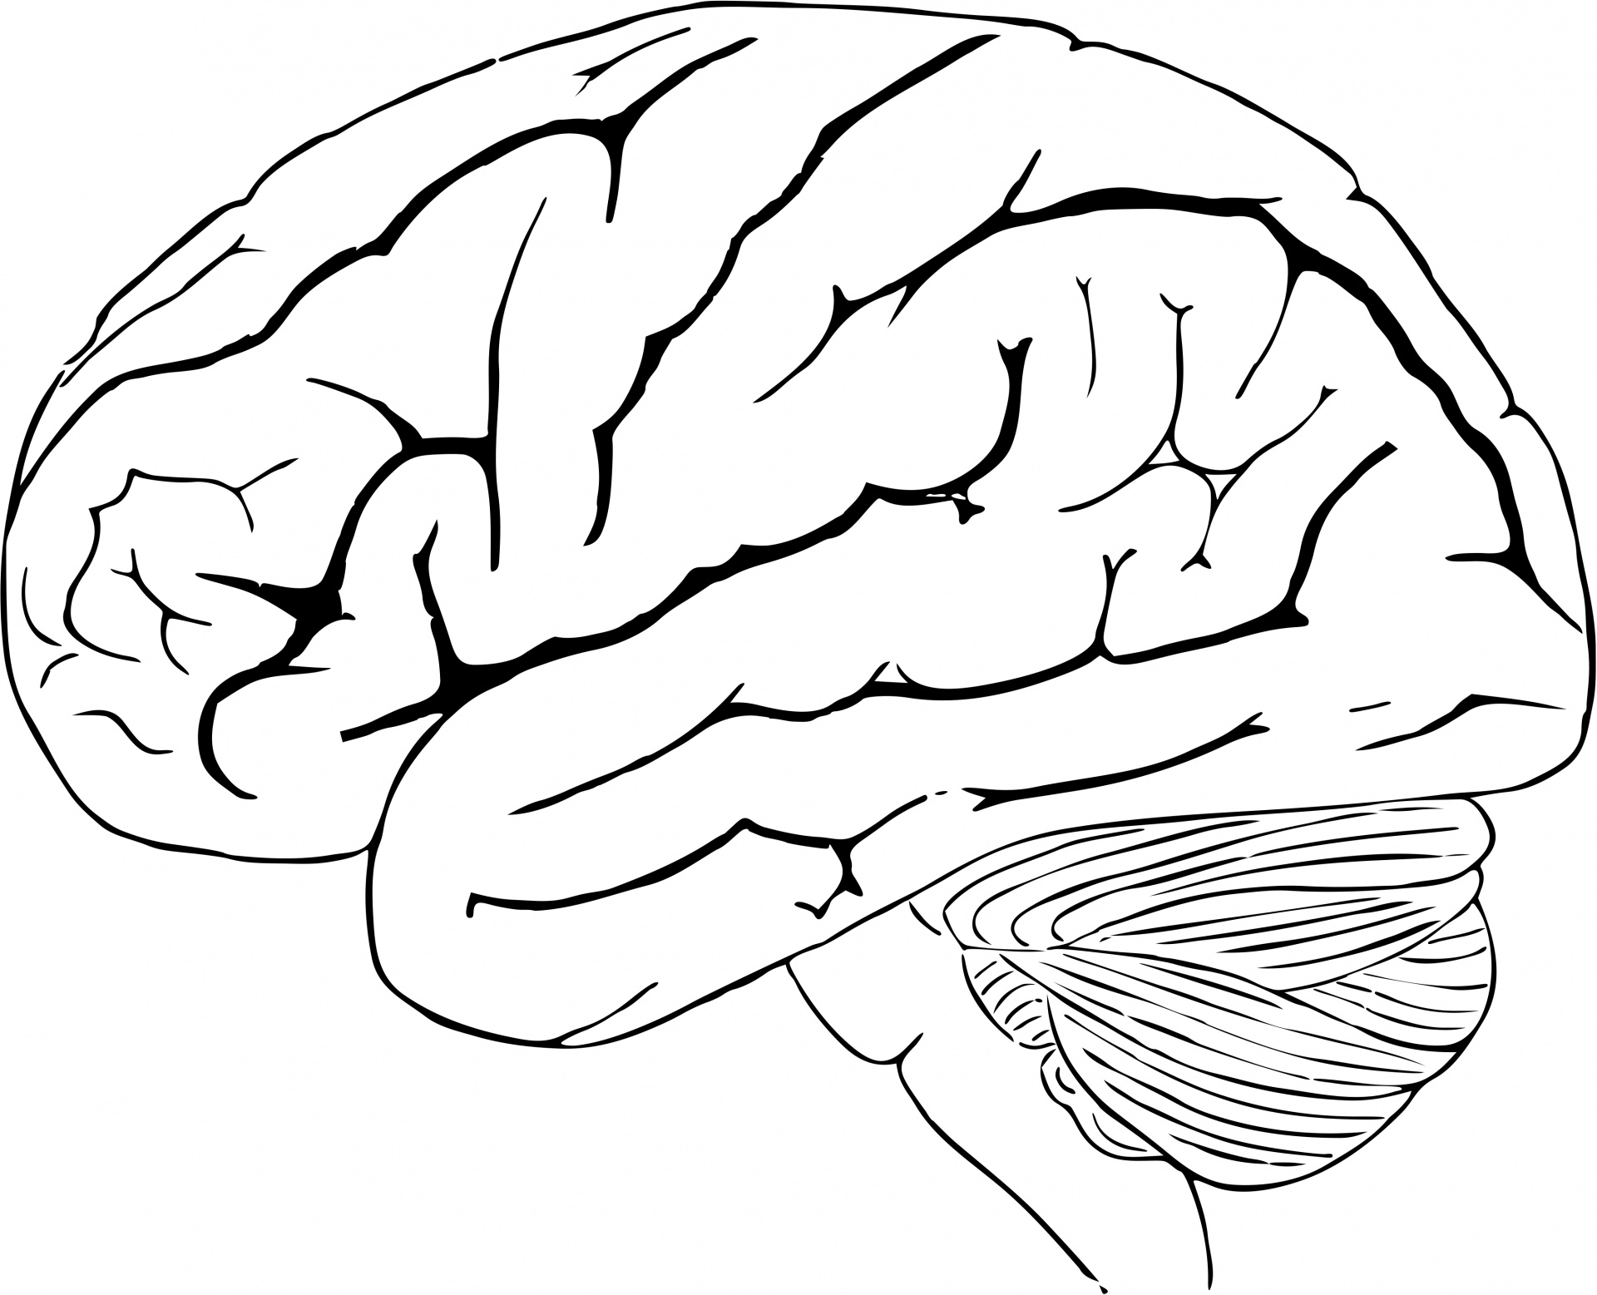
Brain Plasticity Notes
1 Write a definition of brain plasticity. (p.158)
2 Although the brain as a whole does not change in shape, there are ongoing changes to the brain’s physical structure and function. Explain what these are. (second paragraph, p.158)
3 Which parts of the brain have more plasticity than others? (p.158)
4 Write a definition of adaptive plasticity. (p.159)
5 The two important processes underlying recovery after brain damage are rerouting and sprouting. (p.159) Explain what these terms mean and how the processes allow the brain to recover lost function.
6 Adaptive plasticity is also evident in a healthy brain in response to experience. Give an example of this from your textbook. (see pp.160-1)
7 How does brain plasticity contribute to the fact that no two brains are the same?
Text: Grivas, Psychology, VCE Units 1 and 2, 7th edition

Brain Plasticity Notes
1 Write a definition of brain plasticity. (p.158)
2 Although the brain as a whole does not change in shape, there are ongoing changes to the brain’s physical structure and function. Explain what these are. (second paragraph, p.158)
3 Which parts of the brain have more plasticity than others? (p.158)
4 Write a definition of adaptive plasticity. (p.159)
5 The two important processes underlying recovery after brain damage are rerouting and sprouting. (p.159) Explain what these terms mean and how the processes allow the brain to recover lost function.
6 Adaptive plasticity is also evident in a healthy brain in response to experience. Give an example of this from your textbook. (see pp.160-1)
7 How does brain plasticity contribute to the fact that no two brains are the same?
Text: Grivas, Psychology, VCE Units 1 and 2, 7th edition

Brain Plasticity Notes
1 Write a definition of brain plasticity. (p.158)
2 Although the brain as a whole does not change in shape, there are ongoing changes to the brain’s physical structure and function. Explain what these are. (second paragraph, p.158)
3 Which parts of the brain have more plasticity than others? (p.158)
4 Write a definition of adaptive plasticity. (p.159)
5 The two important processes underlying recovery after brain damage are rerouting and sprouting. (p.159) Explain what these terms mean and how the processes allow the brain to recover lost function.
6 Adaptive plasticity is also evident in a healthy brain in response to experience. Give an example of this from your textbook. (see pp.160-1)
7 How does brain plasticity contribute to the fact that no two brains are the same?
Text: Grivas, Psychology, VCE Units 1 and 2, 7th edition

