The Müller-Lyer Illusion

Are people from “carpentered” environments more susceptible to this illusion?

Sometimes we make visual perceptual mistakes. These lapses of judgement provide insight into how our perceptual processes function and which factors influence our interpretation of visual stimuli.

A false visual perception is called an optical illusion. One of the most thoroughly studied illusions is called the Müller-Lyer illusion, in which two lines of equal length appear unequal.

HYPOTHESIS:

METHOD
  - Participants:
  - Materials/Apparatus (draw a simple sketch)
  - Procedure:

RESULTS
Circle Order of Participant: 1 2 | Trial 1 | Trial 2 | Trial 3
Individual
Class Mean Participant 1
Class Mean Participant 2

- Briefly restate the results here in a sentence.

DISCUSSION
  - Is the data qualitative or quantitative? Explain.

  - How reliable do you think our findings are? Explain your answer. Reliable in this case means: “consistent” or “likely to occur again if the experiment were to be replicated”.

  - Are there any variables that might have influenced our results? How would you overcome such factors?

Are people from “non-angular” environments more susceptible to this illusion?

One Explanation for the Müller-Lyer Illusion

This famous illusion has provoked hundreds of psychological studies.

Our empirical research activity requires the use of an apparatus that allows students to estimate the length of one line against the length of the other.
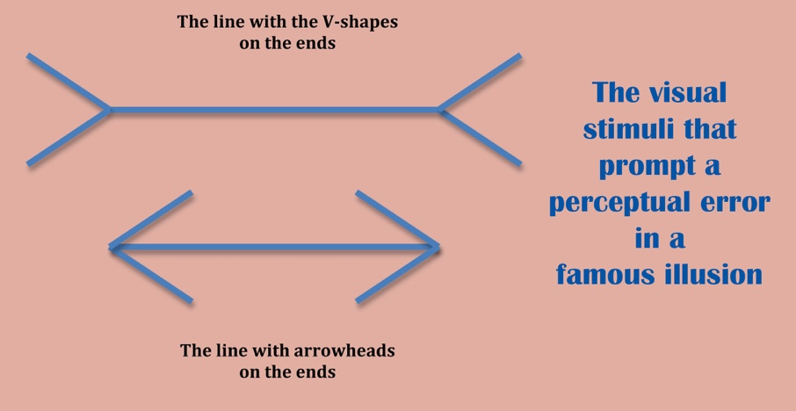
What makes this difficult is that one line has “arrow-heads” while the other has V-shapes emitting from its ends.

These differing line ends, for reasons that have been debated for decades, seem to trick the perceiver into perceiving one line as longer than it actually is and the other as shorter. Here is how the lines look.

One explanation of this illusion is that it is at least partially based on our experience with the angular lines created by the inside and outside corners of buildings. These angular lines suggest either a further away line or a closer one; if we interpret a line of the same length as being further away, we shall naturally perceive it as longer. The picture below illustrates this idea:

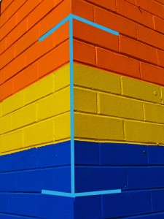
Look at how the lines of the illusion are reflected in the angles in the corner of this building. Since this building corner is pointing towards the viewer, the theory is that we perceive it as being shorter than the corresponding lines in a corner pointing away from the viewer.
Photo: Orange yellow blue, kindly provided by Mimi_K at flickr.com
The lines in this photo are similar to the line with the arrowheads. According to one theory, we perceive this building corner as pointing towards us, so we interpret the vertical line as shorter than when it represents another corner that is receding into the distance.
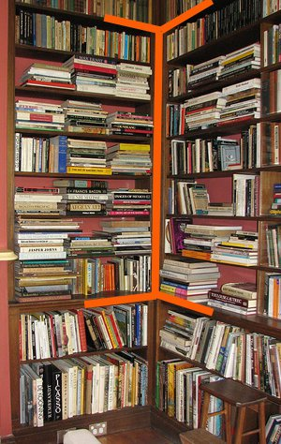
The internal corner is perceived as being further away; consequently, the line is perceived as longer.

If the corner we are viewing is receding from us or pointing away from us, as in the photo below, the lines created by the angles of the corner are like the V-shaped line. We interpret this line as being further away and therefore longer, according to this theory of why the illusion occurs.

The original photograph was provided by Mimi_K at flickr.com and is titled Heide.

Evidence that supports this theory includes studies of people in non-angular environments such as the Kalahari Desert. These desert dwellers displayed greatly reduced susceptibility to the Müller-Lyer illusion. In contrast to the people of “carpentered” societies, they simply were not deceived by the illusion. This suggests that cultural experiences in childhood influence the way in which we interpret certain visual stimuli and apply depth cues.

• An article referring to cultural studies of the Müller-Lyer illusion

