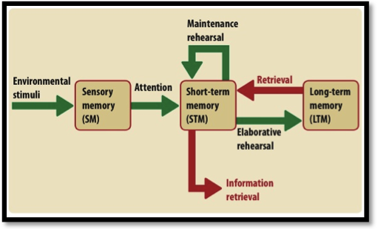
Memory and Forgetting

- Fill in the details on the blank handout for the Atkinson-Shriffrin multi-store model of memory (pp.292-295 of text, following pages also helpful). The simplified model on the right should help you to develop a much more detailed version.

- Complete a detailed concept map of the Craik and Lockhart’s levels of processing framework (pp.312-314 of your text).
- Complete a detailed concept map of Baddeley and Hitch’s model of working memory (pp.316-319).
- Complete the handout with structured questions for taking notes on the theories of forgetting.
- Retrieval failure theory (pp.371-373)
- Interference theory (pp.374-380)
- Motivated forgetting (pp.380-384)
- Decay theory (pp.384-386)
- Watch the videos on the blog about memory. These videos are shown below and may be found
on the blog at http://psychologyrats.edublogs.org/

Right sidebar of blog Right sidebar of blog Right sidebar of blog
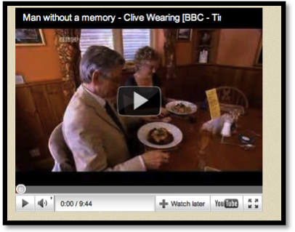

Don’t forget your homework! Have
a great holiday.
This video can be accessed at the blog post titled: Psych Conference News, February 2011.
http://psychologyrats.edublogs.org/2011/02/26/psych-conference-news-february-2011/

